EXPERIMENT – 5
5. Implement a Python function to analyze the histogram of the given input image based on color levels using OpenCV.
Aim
To analyze the histogram of a given input image based on color levels using OpenCV and Matplotlib.
Procedure
- Import the OpenCV and Matplotlib libraries.
- Read the input image using cv2.imread().
- Check whether the image is loaded successfully.
- Define the color channels as Blue, Green, and Red.
- Calculate the histogram for each color channel using cv2.calcHist().
- Plot the histograms of all three color channels.
- Display the color histogram and close the plot window.
Program:
import cv2
import numpy as np

img = cv2.imread("panda.jpg")

kernel = np.ones((5, 5), np.uint8)

eroded = cv2.erode(img, kernel, iterations=1)

cv2.imshow("Original Image", img)
cv2.imshow("Eroded Image", eroded)

cv2.waitKey(0)
cv2.destroyAllWindows()
Sample Input
image.jpg
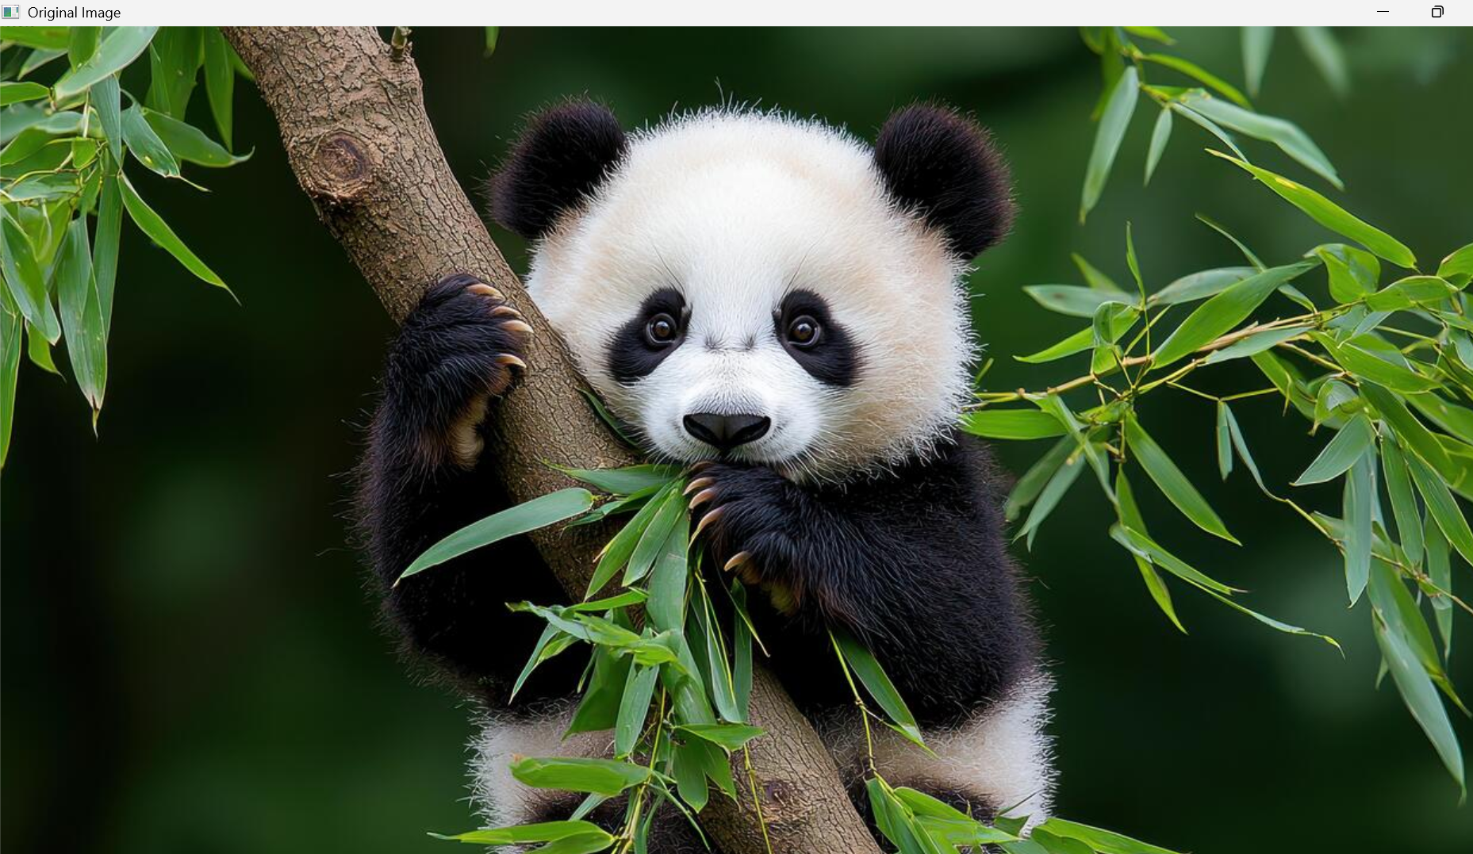
Sample Output
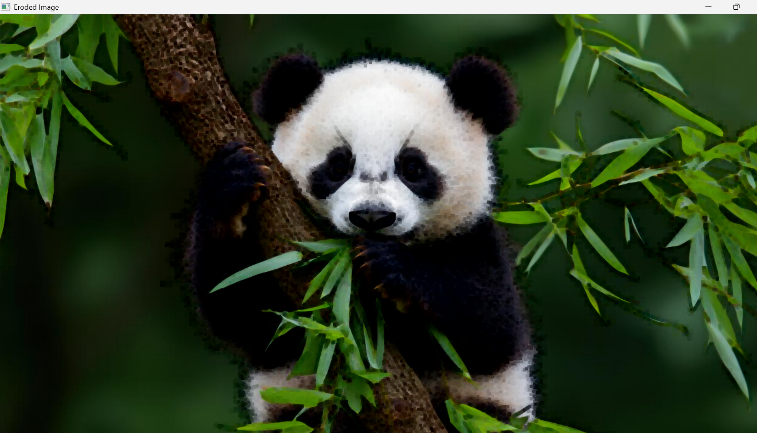
Result
Thus, the histogram of the given input image was successfully analyzed based on Blue, Green, and Red color levels using OpenCV and Matplotlib.

